Sanjib Kumar Pradhan
Cyber Security Engineer | Security Engineer |Ethical Hacking| Network Engineer

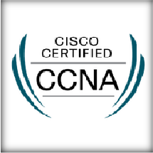ADDRESS
B/203,Nalco Nagar,Angul Odisha Pin: 759145
ss

+91 773-592-8890
sanjibpofficial@gmail.com
www.linkedin.com/in/sanjib pradhan25

TECHNICAL SKILLS

- RDBMS
- C, C++ Programming
- CCNA
- Python
- WAF
- Linux (Kali / CentOS)
- Ethical Hacking
- Network Testing
- Web-Application Penetration Testing
- VAPT (OWASP-2021)

LANGUAGES
- English – Speak, Read & Write
- Hindi – Speak, Read & Write
- Odia – Speak, Read & Write

PERSONAL DETAILS

Father’s Name: Saroj Kumar Pradhan Date of birth: 21 August 1997 Gender: Male
Nationality: Indian
Languages Known: English, Hindi & Odia.
Hobbies: Spending Time Alone (Giving Time to Myself)/Introvert

PROFESSIONAL SUMMARY/TECHNICAL SKILLS
.
  - Configuration & Manage of DNS, DHCP.
  - Configuration & Troubleshooting of VPN.
  - Configuration & Manage of IP addressing & subnetting.
  - Configuration & Manage of routing RIP,EIGRP,OSPF.
  - Configuration & Manage of router.
  - Install all software and antivirus.
  - Hardware assembling (Server, System and peripherals) and troubleshooting also.
  - Configure & Troubleshoot LAN, WAN, WLAN.
  - Network Penetration Testing
  - Web Application Penetration Testing (OWASP TOP 10)
  - Vulnerability Assessment Testing
  - Website Testing Via Acunetix
  - Enumeration/Exploiting with Bug-Bounty
  - Knowledge On IDS/IPS

TOOLS USE: Nmap,Burpsuite,Acunetix,Wireshark,Nessus

EDUCATION
  - Diploma from Adarsh College of Engineering with Aggregate 78% - 2019
  - Bachelor’s Degree from Adarsh College of Engineering with Aggregate 75% - 2022
  - Diploma in Cyber Security - 2022-2023/24

CERTIFICATION
  - CISCO CCNA (CISCO ID-CSCO14588606)

EXPERIENCE
Intern at ISOAH Data & Securities Apr/24-Present
  - Monitoring all vulnerabilities of the website through testing tools.
  - Checking CWE/CVE via CVSS
  - Completed Project On Impact $ Mitigation of Affected URL (http://foophones.securitybrigade.com:8080/)
  - Completed Project on Impact & Mitigation of Affected URL(https://juice- shop.herokuapp.com/)
  - Completed Project on Impact & Mitigation of Affected URL (http://altoro.testfire.net/)
- Ongoing Project on OWASP_Broken_Web_Apps_VM_1.2
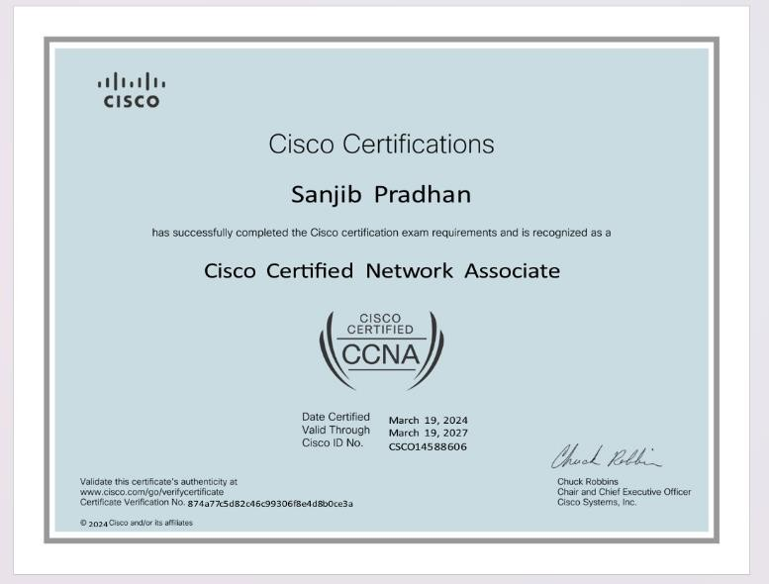
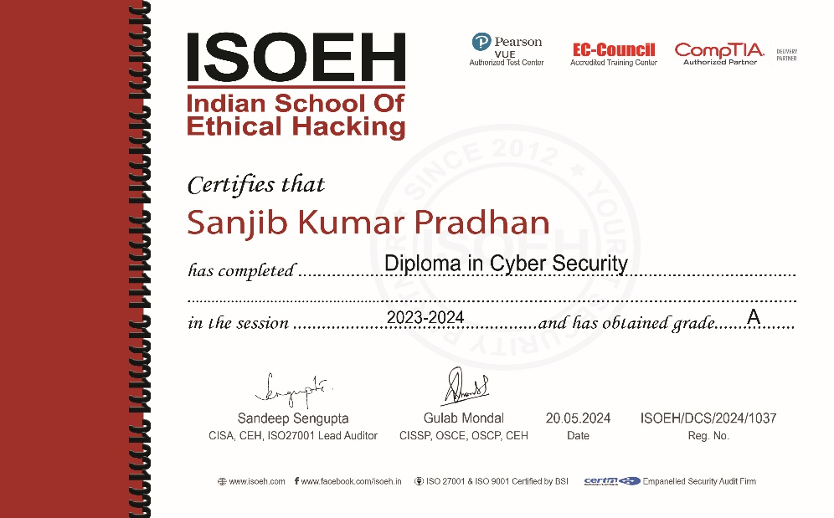

Date:
Sign: Sanjib Kumar Pradhan

